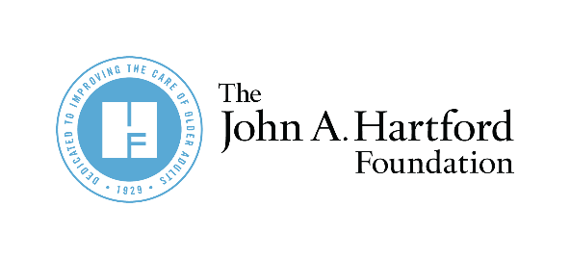
AGE-FRIENDLY INSIGHTS:
Hospitals, Health Systems and Providers

]

Partner Newsletter and Social Copy for
Age-Friendly Insights on Hospitals

Twitter
According to a new poll fielded by @johnahartford, 81% of older adults would rather go to a hospital that provides age-friendly care focusing on what matters to them. Learn more about the findings now. https://bit.ly/AFIHospitals
- Pair with Graphic #3

While most older adults feel positively about U.S. hospitals, 58% of them who visited a hospital in the last three years were not asked about #WhatMatters to them according to a new @johnahartford poll. Read more about the findings. https://bit.ly/AFIHospitals
- Pair with Graphic #2

LinkedIn
According to a new poll commissioned by @The John A. Hartford Foundation, most older adults feel positively about U.S. hospitals and are more likely to visit hospitals that offer age-friendly care. However, 58% of older adults who visited a hospital in the last three years were not asked about what matters to them, a key facet of age-friendly care. Learn more about the findings. https://bit.ly/AFIHospitals

Newsletter
A new poll commissioned by The John A. Hartford Foundation (JAHF) show that most older adults feel positively about U.S. hospitals. At the same time, they prefer hospitals that offer age-friendly care. However, 58% of older adults who visited a hospital in the past three years were not asked about what matters to them, a key attribute of health systems that are age-friendly. Read more about the findings. https://bit.ly/AFIHospitals

