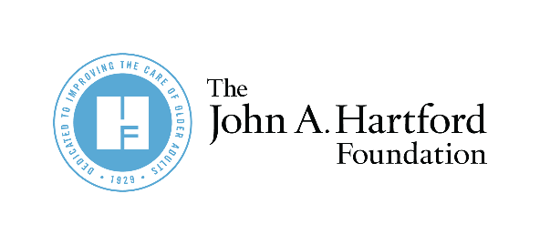

AGE-FRIENDLY INSIGHTS:
Family Caregivers

]

Partner Newsletter and Social Copy for
Age-Friendly Insights on Family Caregivers

Twitter:
Policies to support #FamilyCaregivers are nearly universally popular, regardless of political party, income, age, education, etc. according to a new poll by @johnahartford. Read more about policies supporting family caregivers bit.ly/3gYEbls
- Pair with Graphic #1

A new poll by @johnahartford found 93% of people support paid time off for #FamilyCaregivers to fulfill their responsibilities. Discover other politically popular caregiving policies bit.ly/3gYEbls
- Pair with Graphic #2
LinkedIn:
A new poll by @The John A. Hartford Foundation found that 93% of people support paid time off for family caregivers to fulfill their responsibilities and 90% support guaranteeing unemployment benefits to those who need to leave their jobs to care for someone. Read about the survey findings and how to support family caregivers now. bit.ly/3TQtlwI
- Pair with Graphic #3
Newsletter:
Family caregivers need support now. They are a lifeline for older adults and people with disabilities, providing hands-on care with daily tasks such as bathing and dressing for their friends or family members. According to a new poll commissioned by The John A. Hartford Foundation, the policies recommended in the 2022 National Strategy to Support Family Caregivers have near-universal approval regardless of age, income, education and even political affiliation, specifically:
- 94% support providing free training for family caregivers who need to perform medical tasks; and
- 93% support bringing in professional direct care workers so family caregivers can rest and address their own personal needs.

Learn more about the polling and what actions you can take from the National Strategy.
- Pair with Graphics #4 or #5

