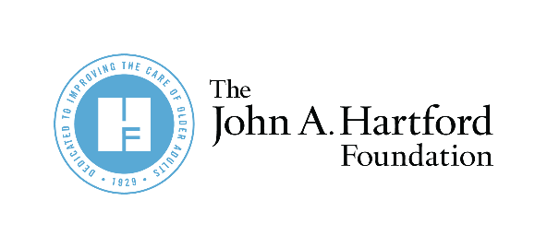

AGE-FRIENDLY INSIGHTS:
Direct care workers need support now.

Partner Newsletter and Social Copy for
Age-Friendly Insights on Direct Care Workers

Twitter
According to a new poll from @johnahartford, 73% of US adults think #DirectCareWorkers are underpaid. Learn more about the findings and how to support direct care workers now https://bit.ly/3IRh595
- Pair with share one

People want the government to help #DirectCareWorkers protect older adults. 94% believe government oversight of nursing homes and home care agencies is important according to a new @johnahartford poll. Learn more https://bit.ly/3IRh595
- Pair with share five

Nearly half of people in a new national poll by @johnahartford said they won’t need support from a #DirectCareWorker. In reality, 66% will. Investing in this workforce today is critical to ensure older adults will have the support they need tomorrow https://bit.ly/3IRh595
- Pair with share two

LinkedIn
Direct care workers need support now. They are a lifeline for older adults and people with disabilities and provide hands-on care with daily tasks like bathing and dressing in peoples’ homes and in long-term care facilities, including nursing homes. According to a new poll commissioned by @The John A. Hartford Foundation, 73% of people in America think direct care workers are underpaid and 94% believe oversight of nursing homes and home care agencies is important. Learn more about the survey’s findings and how to support and grow the direct care workforce. https://bit.ly/3IRh595
- Pair with share four

Newsletter:
A new poll commissioned by The John A. Hartford Foundation (JAHF) found that 73% of people in America think direct care workers are underpaid and 94% believe oversight of nursing homes and home care agencies is important. Learn more about the survey’s findings and how to support and grow the direct care workforce https://bit.ly/3IRh595

