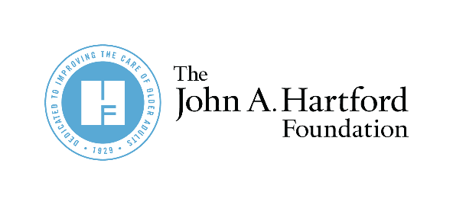

NASEM Nursing Home Report:
A blueprint to transform nursing homes.

Partner Newsletter and Social Copy for NASEM’s Report:
The National Imperative to Improve Nursing Home Quality

Twitter

“READ THE REPORT” MESSAGES (links to NASEM report)
How does the US deliver, finance, regulate, and measure the quality of #NursingHomeCare, and how can this knowledge be used to improve #NHqualitycare? Find out in this new report from @NASEM_Health. Read now: https://bit.ly/3j1nQun

Nursing homes play a unique dual role in the long-term care continuum, serving as a place where people receive needed health care and a place they call home. Learn about strategies for improving #NHqualitycare in this new report from @NASEM_Health: https://bit.ly/3j1nQun

This new @NASEM_Health #NursingHomeStudy examines how the United States delivers, finances, regulates, and measures the quality of #NursingHomeCare: https://bit.ly/3j1nQun

“CALL TO ACTION” MESSAGES (links to JAHF resources)
@NASEM_Health’s report makes clear: the way the US finances, delivers, and regulates #NursingHomeCare is ineffective, inefficient, fragmented, & unsustainable. @johnahartford and its grantees are ready to be part of the solution. Join us: https://bit.ly/3uXpKS7

@NASEM_Health’s report calls improving nursing homes a national imperative. Join @johnahartford in advancing the report’s 7 goals and actionable recommendations to improve #NursingHomeCare: https://bit.ly/3uXpKS7

Immediate action is needed to improve #NursingHomeCare. Join @johnahartford, its grantees and report co-funders @commonwealthfnd, Fan Fox and Leslie R Samuels Found & Sephardic Found in advancing these critical recommendations from @NASEM_Health: https://bit.ly/3uXpKS7

Listen to @johnahartford’s President Terry Fulmer on the urgency of now to transform #NursingHomeCare based on @NASEM_Health report recommendations. https://bit.ly/3xd2dzk

LinkedIn/Facebook

@NASEM Health and Medicine Division released recommendations to improve #NursingHomeCare. Join @The John A. Hartford Foundation, JAHF grantees and co-funders @The Commonwealth Fund, Fan Fox and Leslie R. Samuels Foundation and the Sephardic Foundation of Aging to advance these critical recommendations to improve care for older adults. https://bit.ly/3j1nQun

Newsletter

The National Academies of Sciences, Engineering, and Medicine’s much-anticipated nursing home recommendations underscore the need for critical changes to the way America finances, delivers, regulates, and measures the quality of care in nursing homes.
NASEM's The National Imperative to Improve Nursing Home Quality: Honoring Our Commitment to Residents, Families, and Staff includes detailed recommendations on:
• Bolstering nursing home staff
• Ensuring equitable, person-centered care
• Redesigning quality measures, and more
Co-sponsored by The John A. Hartford Foundation, the report from NASEM’s Committee on the Quality of Care in Nursing Homes identifies seven broad goals, which provide the overarching framework for a comprehensive approach to improving the quality of care in nursing homes. The committee presents an interrelated set of detailed recommendations to achieve each of these goals.

Social Media Graphics

Download social media graphics.

###

For this document and additional information, visit JAHF’s Dissemination Center post.

