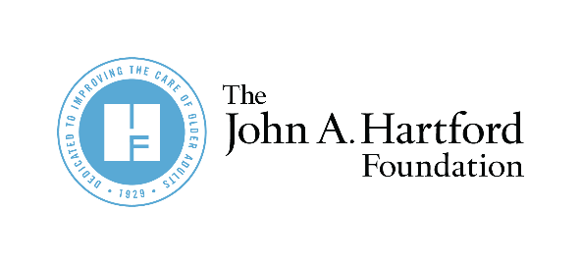

AGE-FRIENDLY INSIGHTS:
Now is the time to redesign nursing home care.

Partner Newsletter and Social Copy for
Age-Friendly Insights on Nursing Homes

Twitter
According to a new poll commissioned by @johnahartford, 57% of older adults say COVID-19 has affected their view of nursing homes and 71% are unwilling to live in one in the future. We are working to change that. #AgeFriendly https://bit.ly/3IfT8J3
Nursing homes are facing an existential crisis: 84% of older adults say they need to see significant changes before they’d consider living in one according to a new @johnahartford poll. What needs to change? #AgeFriendly https://bit.ly/3IfT8J3
57% of older adults say COVID-19 influenced whether they’d ever be willing to live in a nursing home in a new poll by @johnahartford. Older adults deserve safe long-term care options. Now is the time to redesign nursing home care. #AgeFriendly https://bit.ly/3IfT8J3
LinkedIn
From inadequately trained and compensated staff to deficiencies in infection control practices, COVID-19 brought long-standing problems in nursing homes to the forefront. According to a new poll commissioned by @The John A. Hartford Foundation, 71% of older adults say they are very unwilling to live in a nursing home in the future. A collapse of the nursing home industry could decimate our national and local economies and reduce safe care options for older adults at a time when more options are desperately needed. Now is the time to redesign nursing home care. #AgeFriendly https://bit.ly/3IfT8J3

Newsletter
A new poll commissioned by The John A. Hartford Foundation (JAHF) found that 84% of older adults think nursing homes need significant changes and 71% are unwilling to ever live in one. Learn more about what older adults have to say about nursing homes and how JAHF and its partners are redesigning nursing home care for the future. #AgeFriendly https://bit.ly/3IfT8J3

